**Qwik Events Comments and Bugs**

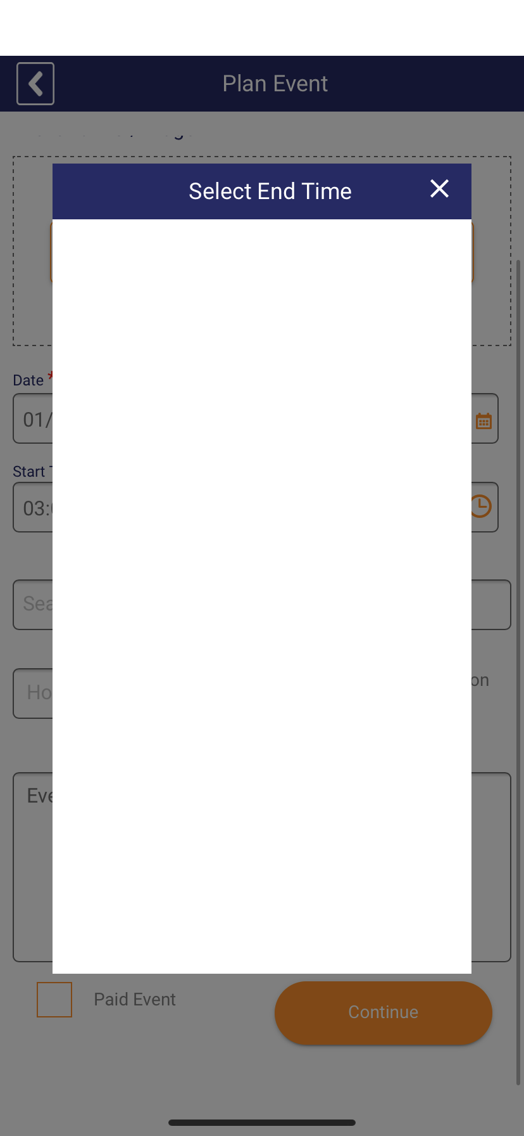

**Sometimes the end time for the event shows no times in the list.**

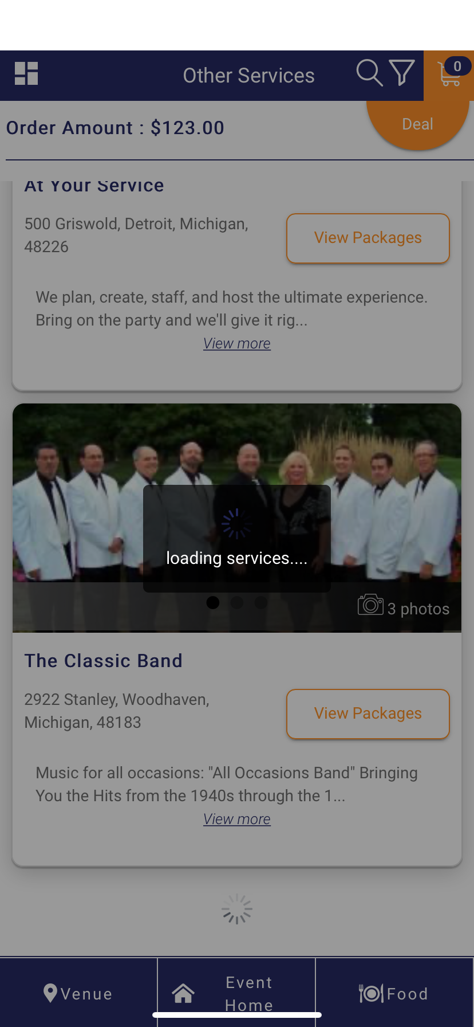

**As a user, I would like to scroll the page even when it is loading more services.**

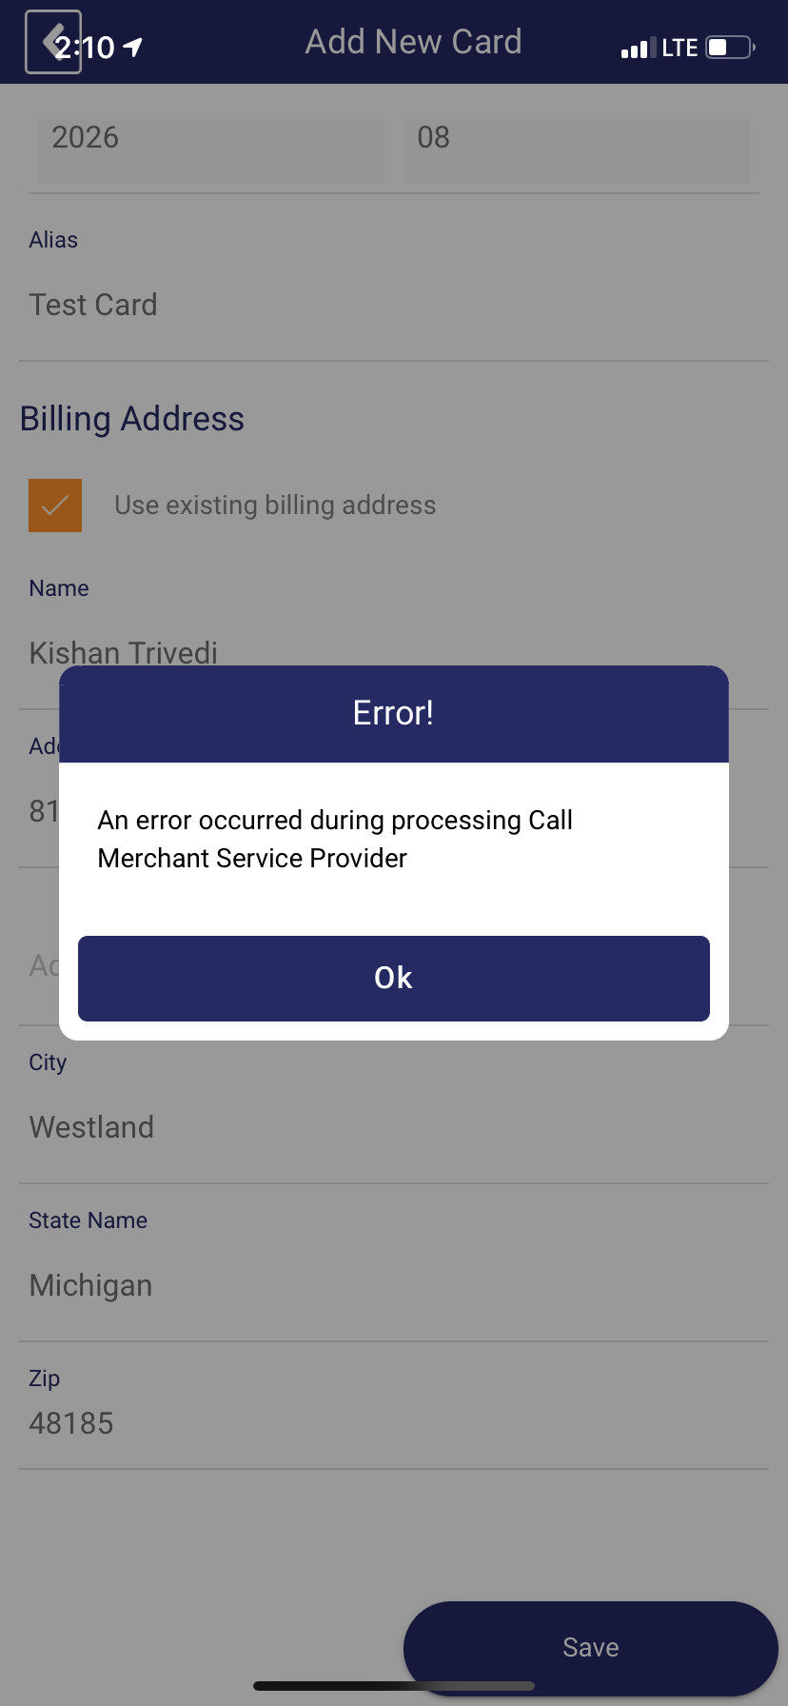

**The back button at the top of the screen blends in to the top bar of the phone.**

**Further Notes**

**Receive a notification (either on the phone screen or in the App itself) when an event invitation is received**

* **Maybe a simple bubble over the 'Invited Events' Button with the number of invitations that are still pending**

**Display in Invitation (checkbox for phone) does not check for a valid phone number or any phone number**

* **As of now, I can click on the checkbox and proceed to next step without entering a phone number**

**Deleting Guests from the Add Invitees page and then clicking Home does not persist the changes**

* **The guests are back on the list**

**Choosing from a list, it doesn't close the list even after clicking on the choice**

**Can an event be more than one day long?**

* **On the phone, it says an event must end on the same day as it starts**